**Remaining Lab topics:**

LRC = 2D parity (Program No:11)

Checksum = Addition Method (Program No:11)

CRC = Division Method (Program No:12)

Hamming Code : (Program No:13)

Leaky Bucket : (Program No:14)

Token Bucket : (Program No:15)

**Program 11 LRC :**

#include <stdio.h>

// Function to calculate LRC

unsigned char calculateLRC(unsigned char *data, int length) {

unsigned char lrc = 0;

for (int i = 0; i < length; i++) {

lrc += data[i];

}

// Take the one's complement of the sum

lrc = (~lrc) + 1;

return lrc;

}

// Function to print a byte in binary format

void printBinary(unsigned char byte) {

for (int i = 7; i >= 0; i--) {

printf("%d", (byte >> i) & 1);

}

}

int main() {

// Example data to be sent (replace this with your actual data)

unsigned char dataToSend[] = {0x41, 0x42, 0x43, 0x44}; // "ABCD" in ASCII

int dataLength = sizeof(dataToSend) / sizeof(dataToSend[0]);

// Calculate LRC for the data

unsigned char lrc = calculateLRC(dataToSend, dataLength);

// Append LRC to the data

dataToSend[dataLength] = lrc;

// Display the data with appended LRC in binary format

printf("Data with appended LRC (in binary):\n");

for (int i = 0; i < dataLength + 1; i++) {

printBinary(dataToSend[i]);

printf(" ");

}

printf("\n");

return 0;

}

**Program 11 Checksum:**

#include<stdio.h>

#include<math.h>

int sender(int arr[10],int n)

{

int checksum,sum=0,i;

printf("\n***SENDER SIDE*\n");

for(i=0;i<n;i++)

sum+=arr[i];

printf("SUM IS: %d",sum);

checksum=~sum; //1's complement of sum

printf("\nCHECKSUM IS:%d",checksum);

return checksum;

}

void receiver(int arr[10],int n,int sch)

{

int checksum,sum=0,i;

printf("\n\n***RECEIVER SIDE*\n");

for(i=0;i<n;i++)

sum+=arr[i];

printf("SUM IS:%d",sum);

sum=sum+sch;

checksum=~sum; //1's complement of sum

printf("\nCHECKSUM IS:%d",checksum);

}

void main()

{

int n,sch,rch;

printf("\nENTER SIZE OF THE STRING:");

scanf("%d",&n);

int arr[n];

printf("ENTER THE ELEMENTS OF THE ARRAY TO CALCULATE CHECKSUM:\n");

for(int i=0;i<n;i++)

{

scanf("%d",&arr[i]);

}

sch=sender(arr,n);

receiver(arr,n,sch);

}

**Output:**

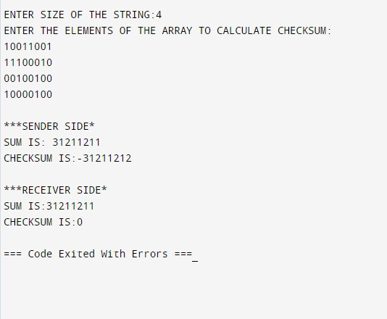

**Program 12 CRC:**

#include<stdio.h>

#include<string.h>

// length of the generator polynomial

#define N strlen(gen_poly)

// data to be transmitted and received

char data[28];

// CRC value

char check_value[28];

// generator polynomial

char gen_poly[10];

// variables

int data_length,i,j;

// function that performs XOR operation

void XOR(){

// if both bits are the same, the output is 0

// if the bits are different the output is 1

for(j = 1;j < N; j++)

check_value[j] = (( check_value[j] == gen_poly[j])?'0':'1');

}

// Function to check for errors on the receiver side

void receiver(){

// get the received data

printf("Enter the received data: ");

scanf("%s", data);

printf("\n-----------------------------\n");

printf("Data received: %s", data);

// Cyclic Redundancy Check

crc();

// Check if the remainder is zero to find the error

for(i=0;(i<N-1) && (check_value[i]!='1');i++);

if(i<N-1)

printf("\nError detected\n\n");

else

printf("\nNo error detected\n\n");

}

void crc(){

// initializing check_value

for(i=0;i<N;i++)

check_value[i]=data[i];

do{

// check if the first bit is 1 and calls XOR function

if(check_value[0]=='1')

XOR();

// Move the bits by 1 position for the next computation

for(j=0;j<N-1;j++)

check_value[j]=check_value[j+1];

// appending a bit from data

check_value[j]=data[i++];

}while(i<=data_length+N-1);

// loop until the data ends

}

int main()

{

// get the data to be transmitted

printf("\nEnter data to be transmitted: ");

scanf("%s",data);

printf("\n Enter the Generating polynomial: ");

// get the generator polynomial

scanf("%s",gen_poly);

// find the length of data

data_length=strlen(data);

// appending n-1 zeros to the data

for(i=data_length;i<data_length+N-1;i++)

data[i]='0';

printf("\n----------------------------------------");

// print the data with padded zeros

printf("\n Data padded with n-1 zeros : %s",data);

printf("\n----------------------------------------");

// Cyclic Redundancy Check

crc();

// print the computed check value

printf("\nCRC or Check value is : %s",check_value);

// Append data with check_value(CRC)

for(i=data_length;i<data_length+N-1;i++)

data[i]=check_value[i-data_length];

printf("\n----------------------------------------");

// printing the final data to be sent

printf("\n Final data to be sent : %s",data);

printf("\n----------------------------------------\n");

// Calling the receiver function to check errors

receiver();

return 0;

}

**Output:**

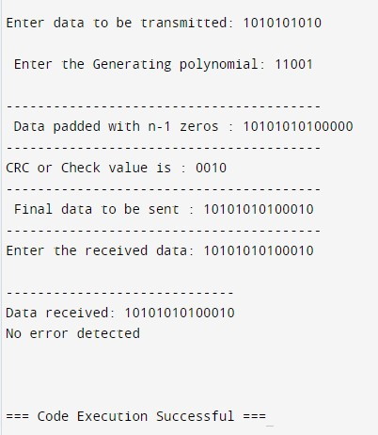

**Practical No. 13 Hamming Code :**

#include <stdio.h>

#include <math.h>

int input[32];

int code[32];

int ham_calc(int,int);

void main()

{

int n,i,p_n = 0,c_l,j,k;

printf("Please enter the length of the Data Word: ");

scanf("%d",&n);

printf("Please enter the Data Word:\n");

for(i=0;i<n;i++)

{

scanf("%d",&input[i]);

}

i=0;

while(n>(int)pow(2,i)-(i+1))

{

p_n++;

i++;

}

c_l = p_n + n;

j=k=0;

for(i=0;i<c_l;i++)

{

if(i==((int)pow(2,k)-1))

{

code[i]=0;

k++;

}

else

{

code[i]=input[j];

j++;

}

}

for(i=0;i<p_n;i++)

{

int position = (int)pow(2,i);

int value = ham_calc(position,c_l);

code[position-1]=value;

}

printf("\nThe calculated Code Word is: ");

for(i=0;i<c_l;i++)

printf("%d",code[i]);

printf("\n");

printf("Please enter the received Code Word:\n");

for(i=0;i<c_l;i++)

scanf("%d",&code[i]);

int error_pos = 0;

for(i=0;i<p_n;i++)

{

int position = (int)pow(2,i);

int value = ham_calc(position,c_l);

if(value != 0)

error_pos+=position;

}

if(error_pos == 1)

printf("The received Code Word is correct.\n");

else

printf("Error at bit position: %d\n",error_pos);

}

int ham_calc(int position,int c_l)

{

int count=0,i,j;

i=position-1;

while(i<c_l)

{

for(j=i;j<i+position;j++)

{

if(code[j] == 1)

count++;

}

i=i+2*position;

}

if(count%2 == 0)

return 0;

else

return 1;

}

**OUTPUT :**

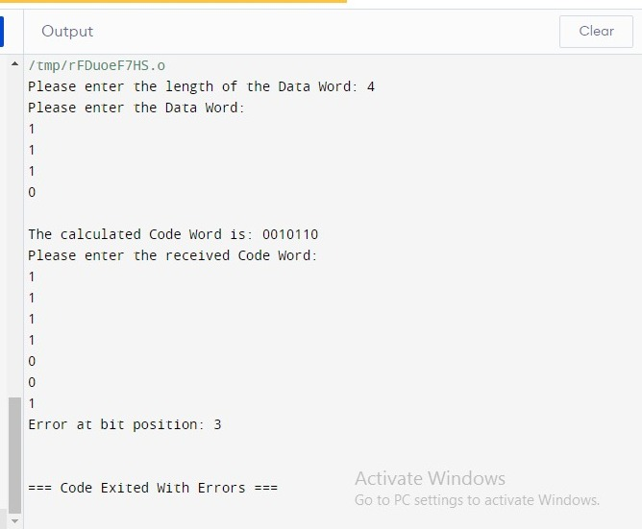

**Program 14 Leaky Bucket :**

#include <stdio.h>

#include <stdlib.h>

#include <unistd.h> // For sleep function

int main() {

int i, packets[10], content = 0, newcontent, time, clk, bucket_size, output_rate;

// Generate random packet sizes

for (i = 0; i < 5; i++) {

packets[i] = rand() % 10;

if (packets[i] == 0)

i--; // Regenerate if packet size is 0

}

printf("\nEnter output rate of the bucket: ");

scanf("%d", &output_rate);

printf("\nEnter Bucket size: ");

scanf("%d", &bucket_size);

for (i = 0; i < 5; ++i) {

if ((packets[i] + content) > bucket_size) {

if (packets[i] > bucket_size)

printf("\nIncoming packet size %d greater than the size of the bucket\n", packets[i]);

else

printf("\nBucket size exceeded\n");

} else {

newcontent = packets[i];

content += newcontent;

printf("\nIncoming Packet: %d\n", newcontent);

printf("Transmission left: %d\n", content);

time = rand() % 10;

printf("Next packet will come at: %d\n", time);

for (clk = 0; clk < time && content > 0; ++clk) {

printf("\nLeft time: %d", (time - clk));

sleep(1);

if (content > 0) {

printf("\nTransmitted\n");

if (content < output_rate)

content = 0;

else

content -= output_rate;

printf("Bytes remaining: %d\n", content);

} else {

printf("\nNo packets to send\n");

}

}

}

}

return 0;

}

**Output :**

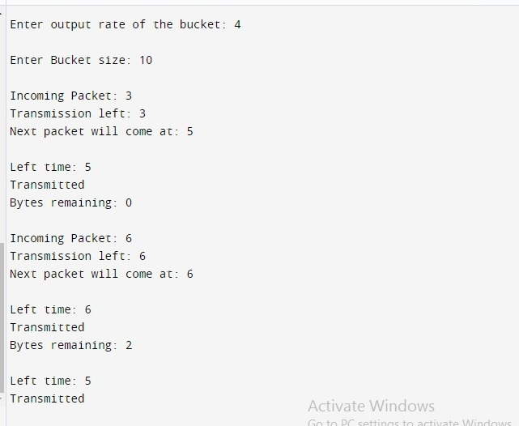

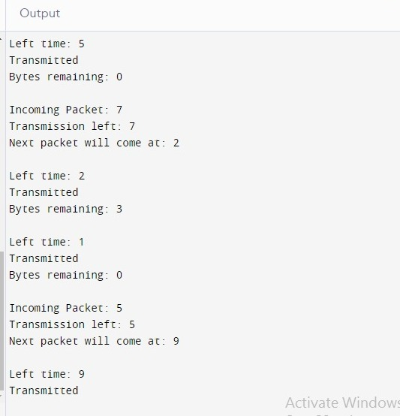

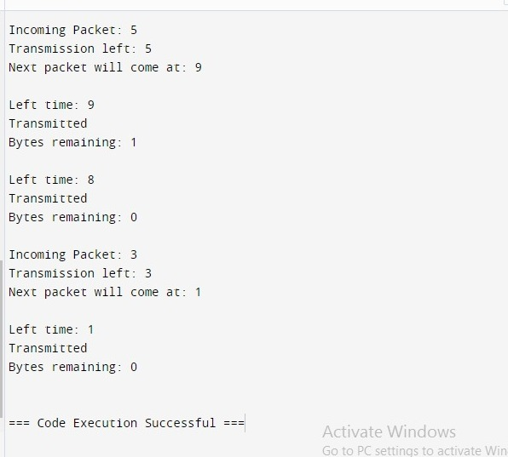

**Program 15 Token Bucket :**

#include <stdio.h>

#include <stdbool.h>

#include <unistd.h> // for usleep function

int main() {

int bucket_size, output_rate;

// User input for bucket size and output rate

printf("Enter the bucket size: ");

scanf("%d", &bucket_size);

printf("Enter the output rate of the bucket: ");

scanf("%d", &output_rate);

int bucket = 0; // Current size of the bucket

while (true) {

// Generate some data, e.g., incoming packets

int incoming_packets;

printf("Enter the number of incoming packets: ");

scanf("%d", &incoming_packets);

// Add incoming packets to the bucket

if (bucket + incoming_packets <= bucket_size) {

bucket += incoming_packets;

} else {

printf("Bucket overflow! Dropping %d packets.\n", incoming_packets + bucket - bucket_size);

bucket = bucket_size; // Bucket is full

}

// Transmit data from the bucket

if (bucket >= output_rate) {

printf("%d packets transmitted.\n", output_rate);

bucket -= output_rate;

} else {

printf("Bucket empty.\n");

}

// Wait for a second before the next iteration

usleep(1000000); // Sleep for 1 second (1 million microseconds)

}

return 0;

}

**Output :**

